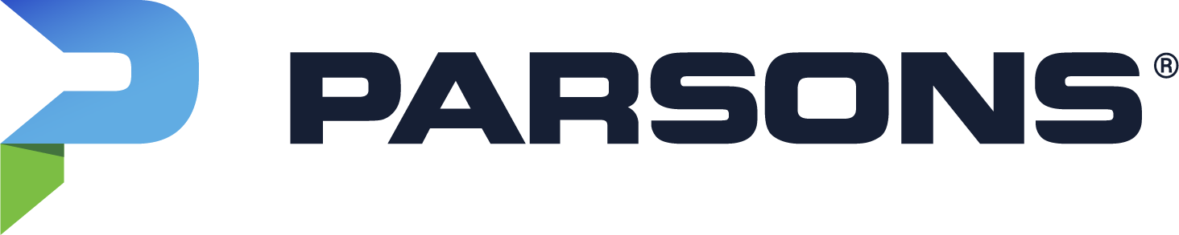
KASKA SCHOLARSHIPS 2026

PROGRAM GUIDELINES
Parsons proudly announces the 2026 Kaska Scholarship Program. Under the Program, two (2) $2500 scholarships will be awarded to Kaska First Nation students, pursing post-secondary education or trades certification related to STEM, the Environmental Remediation field or FMRP Care and Maintenance related trades (such as Electrical, Carpentry, Pipefitters, Millwright, Plumbing or similar).

Eligibility
To be eligible for this scholarship, the recipient must:
- Be a member of the Kaska First Nation
- Be enrolled in a diploma, degree or trades program at any Canadian post-secondary institution or certified trades school.
Priority will be given to students enrolled in studies related to:
- Science, Technology, Engineering and Math (STEM) related to mine remediation such as Environmental Studies, Geology, Earth Sciences, Engineering, Surveying, Computer Sciences, Business Administration; or
- Faro Mine Remediation Project (FMRP) Care and Maintenance related trades (such as Electrical, Carpentry, Pipefitters, Millwright, Plumbing or similar).
Submit the application form including contact information, schooling details, and indicate career goals and how the scholarship will assist in your studies.

How to Apply
Please email the completed scholarship application to rob.yeomans@parsons.com, or mail to:
Parsons Scholarship
Faro Mine Remediation Project
2064 2nd Avenue
Whitehorse, YT
Y1A 1A9

Applications may be downloaded from the Faro Mine Remediation Project website at www.faromineproject.ca or from one of our local offices in Ross River, Faro or Whitehorse.
Deadline to apply is October 1, 2026. Late admissions will not be accepted.

Selection Process
All applications will be reviewed, and recipients will be selected by Parsons FMRP Scholarship Committee. This committee will be comprised of the Socio-economic Development Manager, Kaska Community Liaison, and other individuals as appropriate.
The scholarships will be awarded in December. If you have any questions about this scholarship program, or would like assistance completing your application, please submit any inquiries to: natasha.peter@parsons.com or Whitehorseoffice@parsons.com.

KASKA SCHOLARSHIP APPLICATION FORM

Contact Information
Full Name
Mailing Address
Street:
City: Province/Territory: Postal Code:
Phone Number:
Email Address:
Date of Birth:
Month: Day: Year:

Post-Secondary Information
Name and Location of School:
Program /Field of Study:
Expected Start Date:
Expected Graduation:

Applicant Questions
- Have you worked, studied, or visited the Faro Mine Remediation Work Site? Yes / No

- Please list any other scholarships or financial contributions you have obtained for your schooling:

- Describe your career aspirations after completing your education and how it may be applied to the FMRP?

- Please describe how this award would assist in your studies.

Declaration of Accuracy
I hereby affirm that all the above stated information provided by me is true and correct to the best of my knowledge.
I consent, that if chosen as a scholarship winner, a photo or statement may be taken and used to promote the Faro Mine Remediation Project Scholarship Program.
I hereby understand that if chosen as a scholarship winner, it is my responsibility to submit a certificate of enrollment.

Signature of scholarship applicant: ___________________________ Date: ________________

